**Week 10 - Searching techniques: Linear and Binary**

**1.** To find the frequency of numbers in a list and display in sorted order.

**Constraints:**

1<=n, arr[i]<=100

**Input:**

1 68 79 4 90 68 1 4 5

**output:**

 1 2

 4 2

 5 1

 68 2

 79 1

90 1

**PROGRAM:**

# Input

arr = list(map(int, input().split()))

# Dictionary to store frequency of numbers

frequency_dict = {}

# Count frequency of each number

for num in arr:

if num in frequency_dict:

frequency_dict[num] += 1

else:

frequency_dict[num] = 1

# Sort dictionary by keys

sorted_frequency = sorted(frequency_dict.items())

# Display results

for key, value in sorted_frequency:

print(key, value)

OUTPUT:

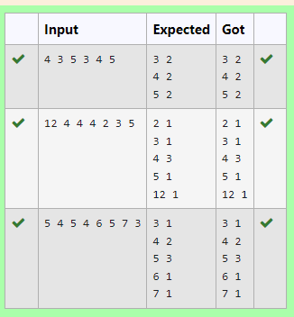

2. Given an listof integers, sort the array in ascending order using the *Bubble Sort* algorithm above. Once sorted, print the following three lines:

1.      List is sorted in numSwaps swaps., where numSwaps is the number of swaps that took place.

2.      First Element: firstElement, the  *first* element in the sorted list.

3.      Last Element: lastElement, the *last* element in the sorted list.

For example, given a worst-case but small array to sort: a=[6,4,1]. It took  3 swaps to sort the array. Output would be

Array is sorted in 3 swaps.

First Element: 1

Last Element: 6

**Input Format**

The first line contains an integer,n , the size of the list a .  
The second line contains  n,  space-separated integers a[i].

**Constraints**

·         2<=n<=600

·         1<=a[i]<=2x106.

**Output Format**

You must print the following three lines of output:

1.      List is sorted in numSwaps swaps., where numSwaps is the number of swaps that took place.

2.      First Element: firstElement, the  *first* element in the sorted list.

3.      Last Element: lastElement, the *last* element in the sorted list.

**Sample Input 0**

3

1 2 3

**Sample Output 0**

List is sorted in 0 swaps.

First Element: 1

Last Element: 3

PROGRAM:

def bubble_sort(arr):

n = len(arr)

swaps = 0

for i in range(n):

for j in range(n - 1):

if arr[j] > arr[j + 1]:

arr[j], arr[j + 1] = arr[j + 1], arr[j]

swaps += 1

return swaps

# Input

n = int(input())

arr = list(map(int, input().split()))

# Sort and count swaps

num_swaps = bubble_sort(arr)

# Output

print("List is sorted in", num_swaps, "swaps.")

print("First Element:", arr[0])

print("Last Element:", arr[-1])

OUTPUT:

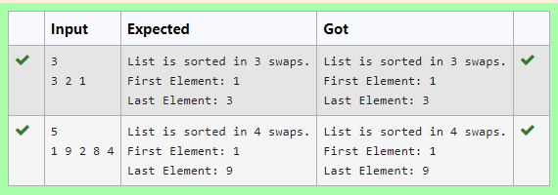

3. An list contains N numbers and you want to determine whether two of the numbers sum to a given number K. For example, if the input is 8, 4, 1, 6 and K is 10, the answer is yes (4 and 6). A number may be used twice.

**Input Format**

The first line contains a single integer n , the length of list

The second line contains n space-separated integers, list[i].

The third line contains integer k.

**Output Format**

Print Yes or No.

**Sample Input**

7

0 1 2 4 6 5 3

1

**Sample Output**

Yes

PROGRAM:

neil=int(input())

a = list(map(int, input().split()))

key=int(input())

fg=0

for i in range(neil):

for j in range(0,neil):

if(a[i]!=a[j]):

if(a[i]+a[j]==key):

fg+=1

if(fg==0):

print("No")

else:

print("Yes")

OUTPUT:

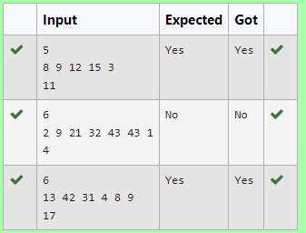

4. Write a Python program for binary search.

**For example:**

| **Input** | **Result** |
| --- | --- |
| 1,2,3,5,8  6 | False |
| 3,5,9,45,42  42 | True |

PROGRAM:

def binary_search(arr, target):

left, right = 0, len(arr) - 1

while left <= right:

mid = (left + right) // 2

if arr[mid] == target:

return True

elif arr[mid] < target:

left = mid + 1

else:

right = mid - 1

return False

arr_input = input()

target_input = input()

arr = list(map(int, arr_input.split(',')))

target = int(target_input)

arr.sort()

result = binary_search(arr, target)

print(result)

OUTPUT:

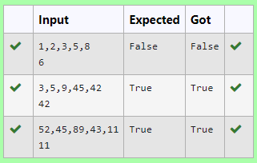

5. Bubble Sort is the simplest sorting algorithm that works by repeatedly swapping the adjacent elements if they are in wrong order. You read an list of numbers. You need to arrange the elements in ascending order and print the result. The sorting should be done using bubble sort.

**Input Format:**The first line reads the number of elements in the array. The second line reads the array elements one by one.

**Output Format:** The output should be a sorted list.

PROGRAM:

def bubbleSort(arr):

n = len(arr)

for i in range(n):

for j in range(0, n-i-1):

if arr[j] > arr[j+1]:

arr[j], arr[j+1] = arr[j+1], arr[j]

n = int(input().strip())

arr = list(map(int, input().strip().split()))

bubbleSort(arr)

print(*arr)

OUTPUT:

